Nama : Ananda Mohammad B

NIM : 18090132

Kelas : 5A

PRAKTIKUM 2

1. Source Code

latihan1-> application/controller

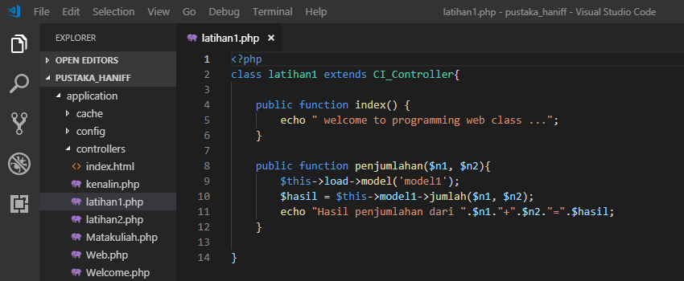

latihan2 -> application/controller

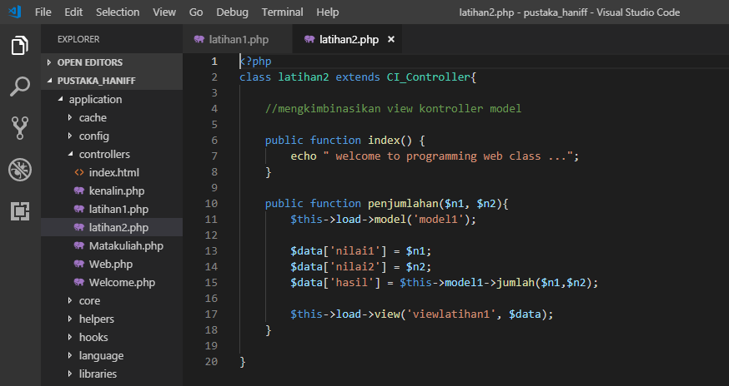

model1 -> application/model

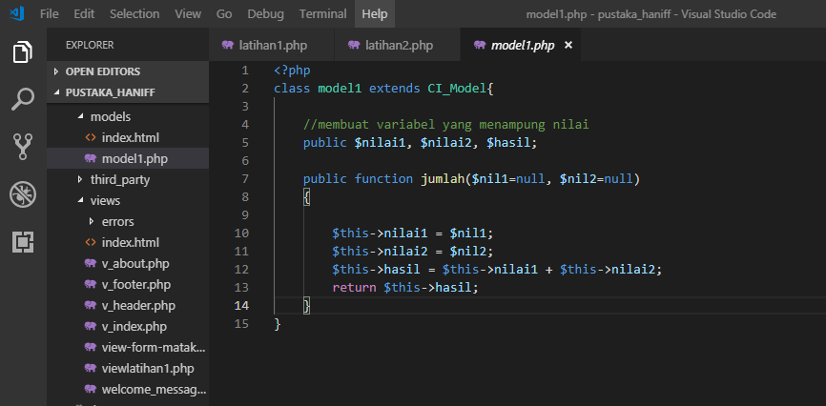

viewlatihan1.php->application/view

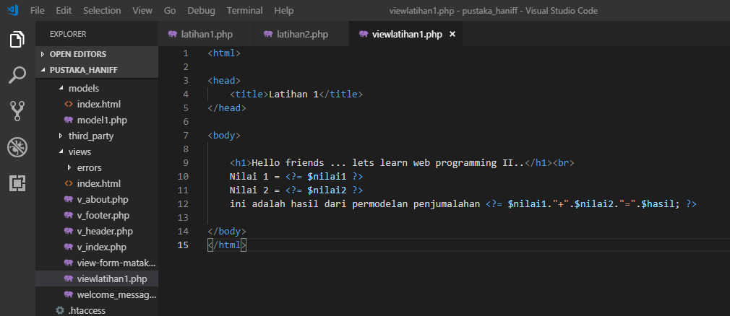

1. URL

<http://localhost/pustaka_ananda/index.php/latihan2>

http://localhost/pustaka_ananda/index.php/latihan2/penjumlahan/4/8

http://localhost/pustaka_ananda/index.php/latihan1/penjumlahan/7/8

1. Capture Hasil

**Hasil run latihan 2**

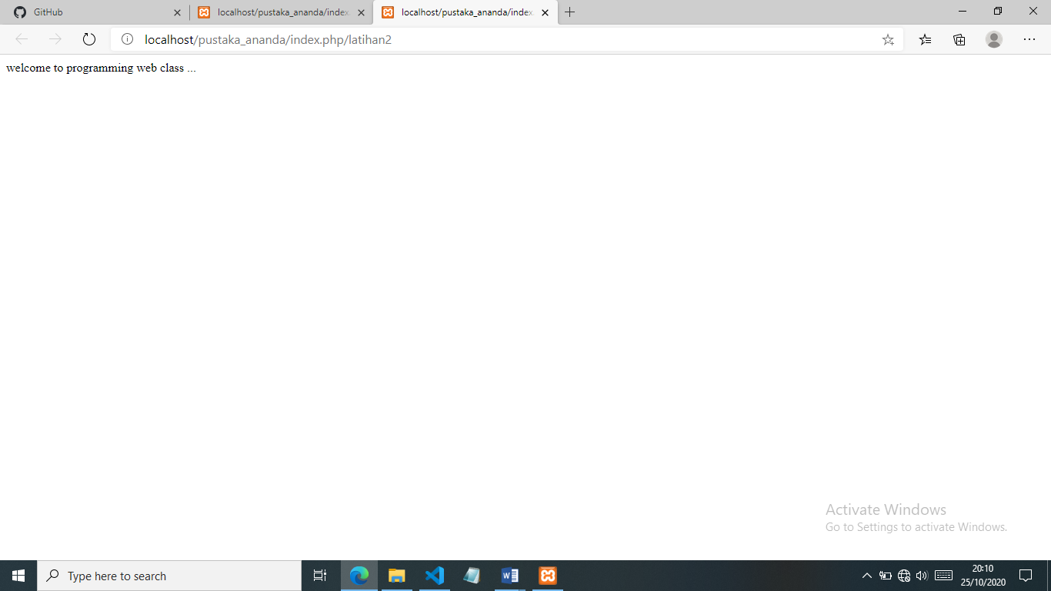

**Hasil run penjumlahan**

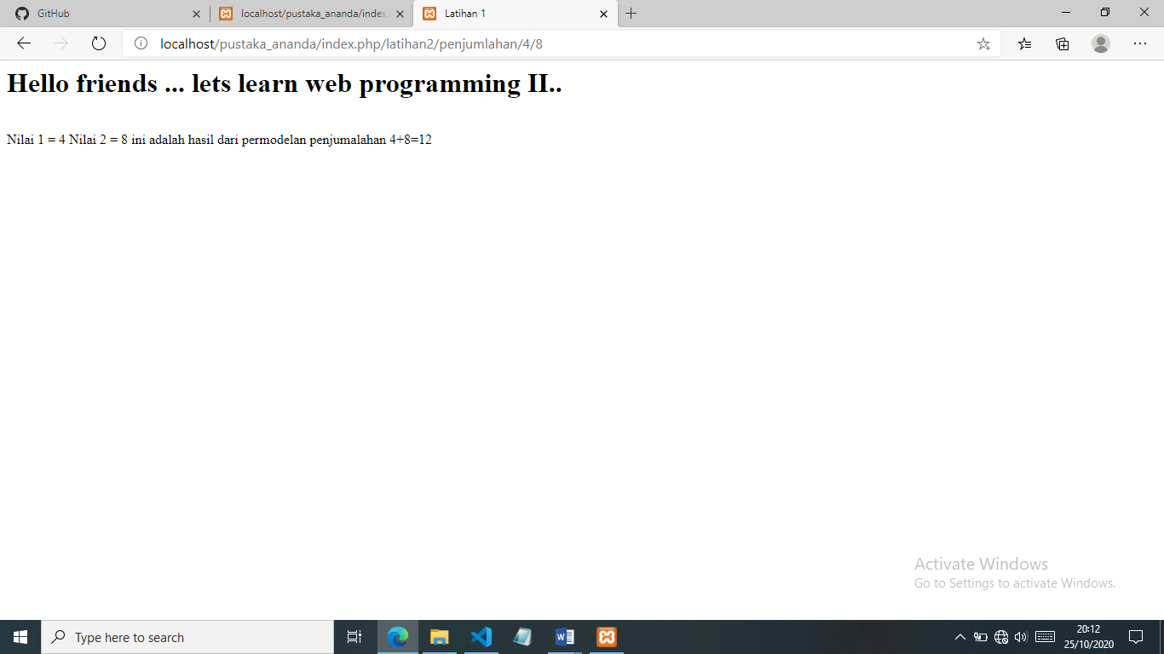

**Hasil run latihan 1**

